# Docker Layer Extraction Utility

## Problem Statement

While transferring the Docker Images to different host *(without Docker registry) or Intel Device*, size of the images would be huge (~500m+). To overcome this issue, Docker images would be exported using *Docker Save command* from the build machine & specific layer where jar/UI artefacts are available, would be extracted and loaded (*using Docker Load command*) to reduce the size of the image.

## Pre-requisites

On the source host from where you want to transfer, type following command

docker save <image name> > <tarball file where you want to save>

docker save rabbitmq > rabbitmq.tar



Transfer the image manually to the target host and type below command

docker load –-input <tarball file>

docker load --input=rabbitmq.tar

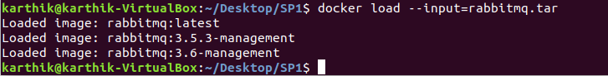

Save and Load Docker Images restores both images and tags.

## SpringBoot Layer - Specific Docker Layer Extraction steps

1. Open *DockerLayerExtract.sh* and update tmpDir to the folder of your choice

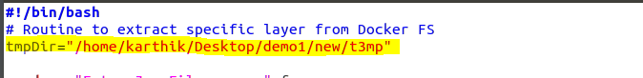

1. Copy the *DockerLayerExtract.sh* script to the folder where you had saved the docker image via *Docker Save* command

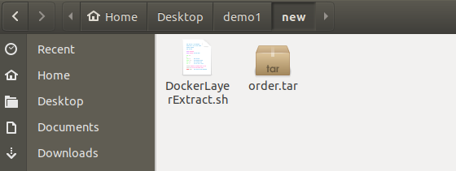

1. Check permissions and execute the *DockerLayerExtract.sh*
   1. Enter Jar filename you want to extract from the image
   2. Specify the tar filename



1. Script execution completed and new tar file would be available in the same path with “new_” prefix

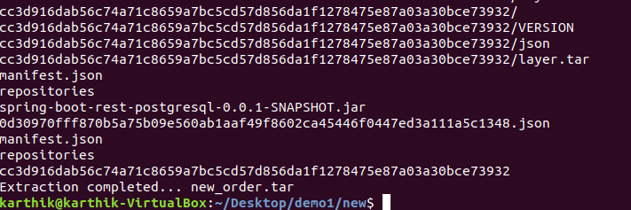

1. New tar file would be available in the same path with “new_” prefix with less size

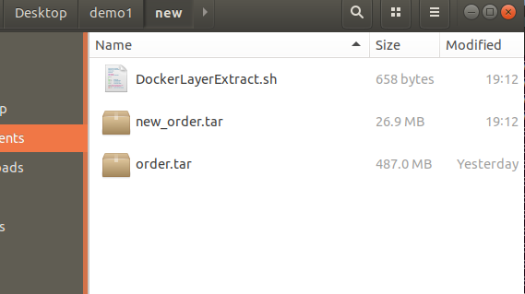

1. [Verification – Optional Step] Check if you can load the tar file via docker load command

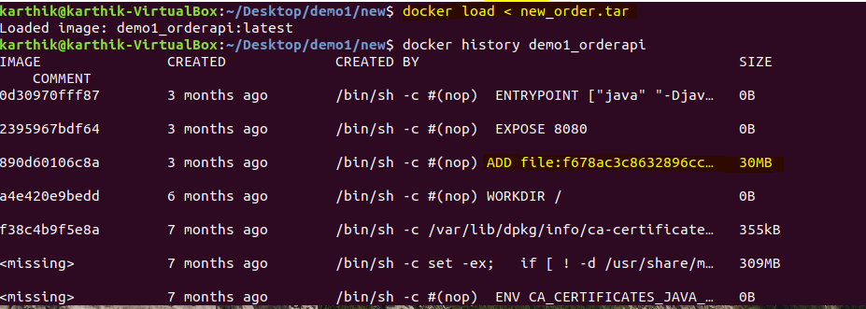

## UI Layer - Specific Docker Layer Extraction steps

1. Open *DockerLayerExtract.sh* and update tmpDir to the folder of your choice



1. Copy the *DockerLayerExtract.sh* script to the folder where you had saved the docker image via *Docker Save* command

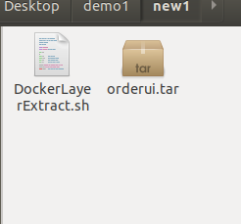

1. Check permissions and execute the *DockerLayerExtract.sh*
   1. Enter term to search for
   2. Specify the tar filename

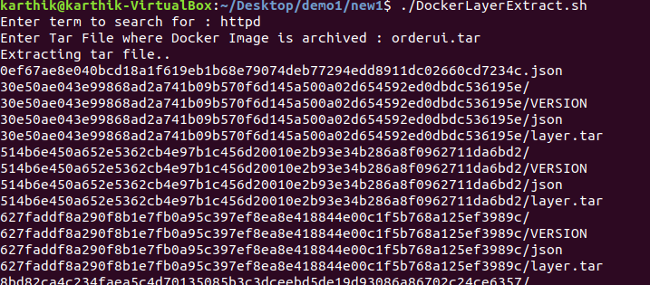

1. Script execution completed and new tar file would be available in the same path with “new_” prefix

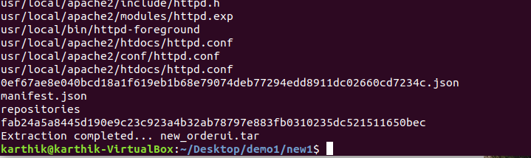

1. New tar file would be available in the same path with “new_” prefix with less size

